**AWS SECRET MANAGER**

**TASK 1. Store and retrieve SSH KEY**

1. Store a new secret.
2. 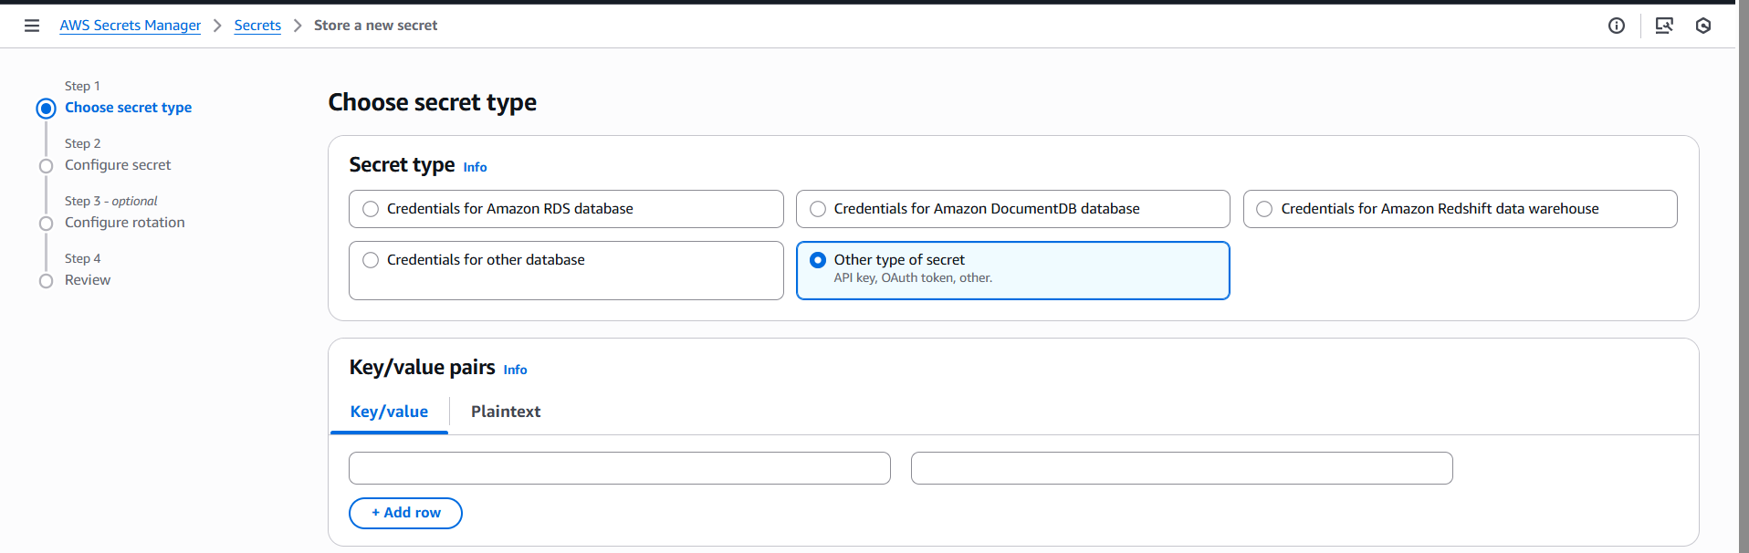
3. 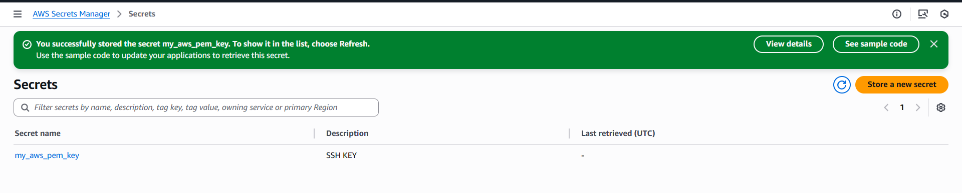
4. list-secrets
5. 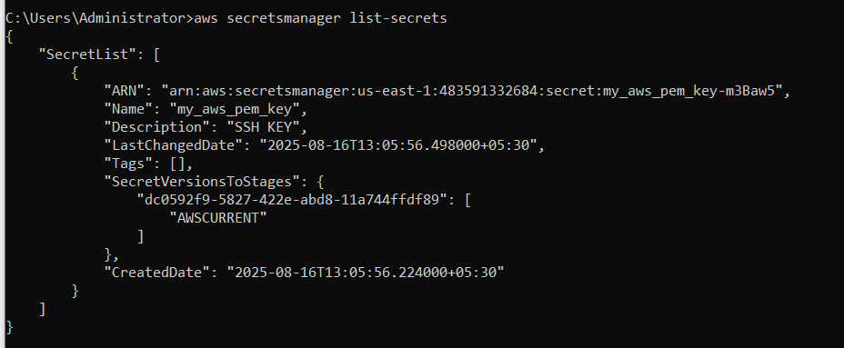
6. get-secret-value
7. 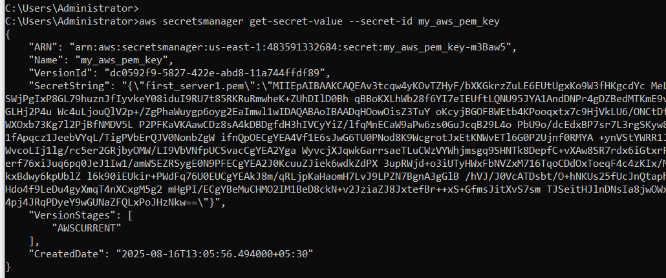

**Task 2: Storing a RDS credentials and enable rotate secret keys**

1. Create a secret key and enable rotation for every 4 hours.
2. 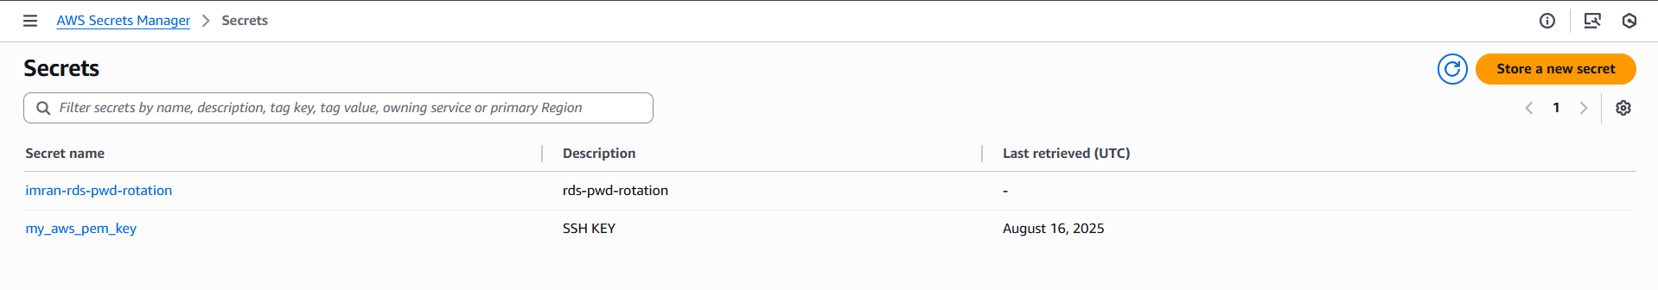
3. 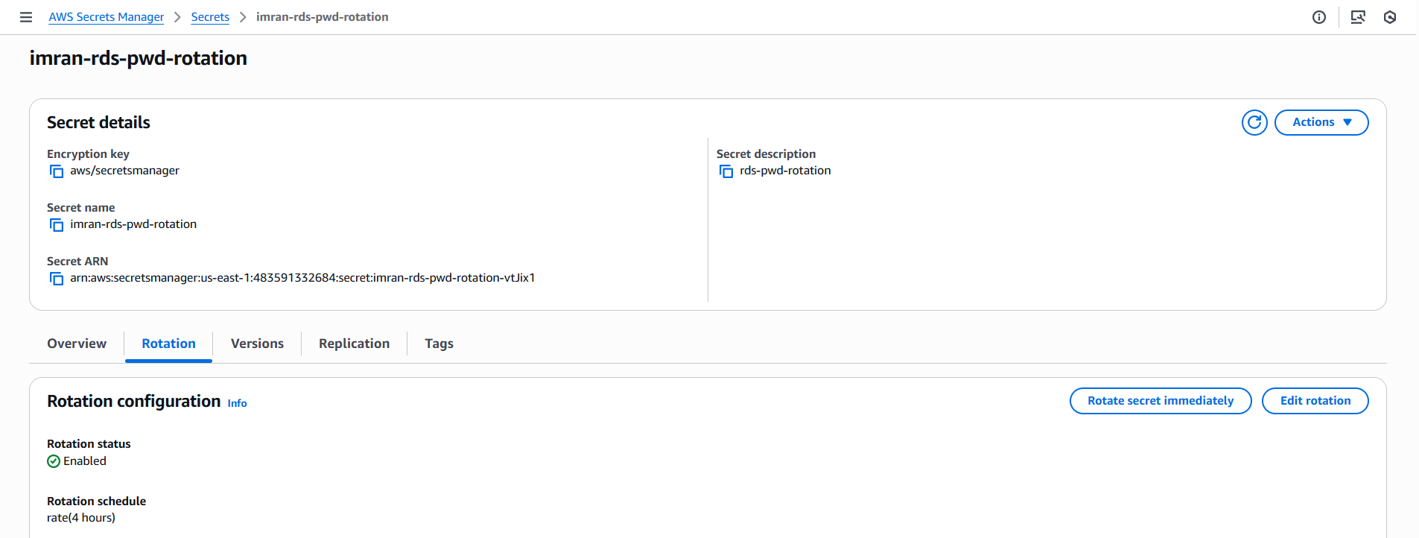
4. List records
5. 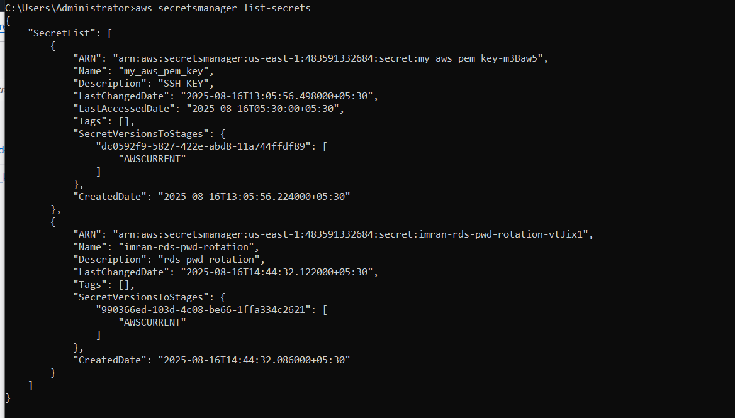
6. After 4 hours its rotated and the password will be changed.
7. 